1. Describe the structure of an artificial neuron.how is it similar to a biological neuron?what are the main components ?

Ans :1) An artificial neuron is a connection point in an artificial neural network. Artificial neural networks like the human body's biological neural network, have a layered architecture and each network node has the capability to process input and forward output to other nodes in the network.

2)Biological neural networks process information in parallel this is also true of artificial neural networks. b. Learning in biological neural networks is through past experiences which improve their performance level this is also true of artificial neural networks.

Main component are :

a.Input :The inputs are simply the measures of our features.

b.Weights : Weights represent scalar multiplications.

c.Transfer Function is different from the other components in that it takes multiple inputs.

d.Activation Function.

e.Bias.

2.what are the different types of activation function popularly used ? Explain each of them

Ans :a.Sigmoid Function : In an ANN, the sigmoid function is a non-linear AF used primarily in feedforward neural networks. .

b.Hyperbolic Tangent Function (Tanh)

c.Softmax Function.

d.Softsign Function.

e.Rectified Linear Unit (ReLU) Function.

d.Exponential Linear Units (ELUs) Function.

Explanation : 1) sigmoid funcation : A sigmoid function is a mathematical function having a characteristic "S"-shaped curve or sigmoid curve.

Formula :

S(x)= \frac {1}{1+e^{-x}}

S(x) = sigmoid function

e = Euler's number

2).Hyperbolic Tangent function: The hyperbolic tangent activation function is also referred to simply as the Tanh (also “tanh” and “TanH“) function. It is very similar to the sigmoid activation function and even has the same S-shape. The function takes any real value as input and outputs values in the range -1 to 1.

3)softmax function : Softmax is a mathematical function that converts a vector of numbers into a vector of probabilities, where the probabilities of each value are proportional to the relative scale of each value in the vector.

Softmax function : σ(z)jσ(z)j=ezjK∑k=1ezkfor j=1,⋯,K.

4) softsign function : The Softsign function is an activation function which rescales the values between -1 and 1 by applying a threshold just like a sigmoid function. The advantage that is the value of a softsign is zero-centered which helps the next neuron during propagating.

5) Rectified Linear Unit (ReLU) Function :

The rectified linear activation function or ReLU for short is a piecewise linear function that will output the input directly if it is positive it will output zero.

6) Exponential Linear Unit (ELU) : was introduced to reduce the bias shift effect and it can achieve faster learning by allowing negative input, which pushes the mean of the activation function closer to zero.

3.

A.explain,in details,Rosenblatt's perceptron model.how can a set of data be classified using a simple perceptron ?

Ans : Rosenblatt perceptron is a binary single neuron model. The inputs integration is implemented through the addition of the weighted inputs that have fixed weights obtained during the training stage. If the result of this addition is larger than a given threshold θ the neuron fires.

B.use a simple perceptron with weights w0,w1 and w2 as -1,2 and 1 respectively,to classify data points(3,4);(5,2);(1,-3);(-8,-3);(-3,0).

4.Explain the basic structure of a multi layer perceptron.explain how it can solve the XOR problem.

Ans : we have built a multi layered perceptron with the following weights and it predicts the output of a XOr logical operator.

Using the formulae for AND, NOT and OR gates, we get:

h1 = σ((1-x1) + x2) = σ((-1)x1 + x2 + 1)

h2 = σ(x1 + (1-x2)) = σ(x1 + (-1)x2 + 1)

y = σ(h1 + h2) = σ(h1 + h2 + 0)

The following is the Truth table for XOr function Truth Table.

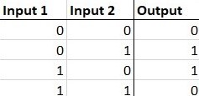

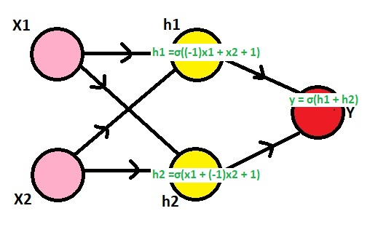

The XOR problem

The XOR problem is that we need to build a Neural Network to produce the truth table related to the XOR logical operator. This is a binary classification problem. Hence, supervised learning is a better way to solve it. Uni layered perceptrons can only work with linearly separable data. But in the following diagram drawn with the truth table of the XOR logical operator.

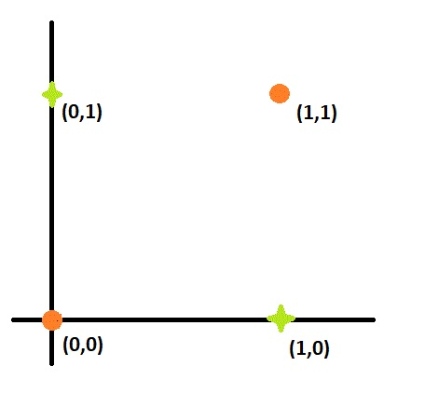

5.what is artificial neural network(ANN)? Explain some of the salient highlights in the different architectural options for ANN.

Ans : Artificial Neural Network (ANN) is an information processing paradigm that is inspired by the brain. an ANN is configured for a specific application such as pattern recognition or data classification through a learning process.

Some salient features :

Speed : faster in processing information response time in nanoseconds.

Processing : serial processing.

Size & complexity : less size & complexity.

Storage: information storage is replaceable means replacing new data with an old one.

Fault tolerance : corrupt information cannot retrieve in case of Failure of the system.

Control mechanism : there is a control unit for controlling computing activities.

6.Explain the learning process of an ANN.explain with an example the challenge in assigning synaptic weights for the interconnection between neurons ? How can this challenge be addressed ?

Ans : An artificial neural networks learning rule or learning process is a method, mathematical logic or algorithm which improves the network's performance and training time.ex. digital logic gate that takes an input and gives an output. "OR" gate, which takes two inputs. If one or both the inputs are "On," then we get "On" in output. If both the inputs are "Off," then we get "Off" in output.

each node is a set of inputs, weight, and a bias value. As an input enters the node, it gets multiplied by a weight value and the resulting output is either observed, or passed to the next layer in the neural network. Often the weights of a neural network are contained within the hidden layers of the network.

Synaptic weight refers to the strength or amplitude of a connection between two nodes.

7.explain in details the backpropagation algorithm what are the limitations of this algorithm?

Ans : Backpropagation Backward propagation is an important mathematical tool for improving of the predictions in data mining and machine learning.

backpropagation is an algorithm used to calculate derivatives quickly.

Backpropagation is an algorithm that back propagates the errors from output nodes to the input nodes.

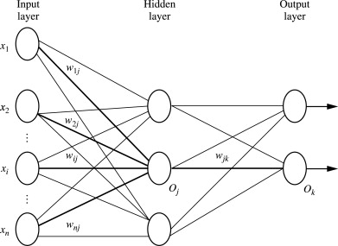

Limitation if this algorithm are :

local minima problem, slow convergence. ,scaling.

8 describe in details the process of adjusting the interconnection weights in a multilayer neural network.

Ans : works by optimizing the weights by considering the error, typically taken as the means squared error and then working to lower it somehow; how exactly they go about doing it is what makes the above algorithms different. Note that this only applies to the first two; reinforcement learning belongs to unsupervised leading, unlike the other the other two, although they can be modified.

9 what are the steps in the backpropagation algorithm ? Why a multi layer neural network is required ?

Ans : Step 1: Inputs X, arrive through the preconnected path.

Step 2: The input is modeled using true weights W. Weights are usually chosen randomly.

Step 3: Calculate the output of each neuron from the input layer to the hidden layer to the output layer.

Step 4: Calculate the error in the outputs

Backpropagation Error= Actual Output

Step 5: From the output layer, go back to the hidden layer to adjust the weights to reduce the error.

Step 6: Repeat the process until the desired output is achieved.

The backpropagation algorithm performs learning on a multilayer feed-forward neural network. It learns a set of weights for prediction of the class label of tuples. A multilayer feed-forward neural network consists of an input layer one or more hidden layers and output layer.

10.write short notes on :

1) Artificial neuron :An artificial neuron is a connection point in an artificial neural network. Artificial neural networks like the human body's biological neural network, have a layered architecture and each network node has the capability to process input and forward output to other nodes in the network.

Artificial neurons are modeled after the hierarchical arrangement of neurons in biological sensory systems. In the visual system for ex: light input passes through neurons in successive layers of the retina before being passed to neurons in the thalamus of the brain and then on to neurons in the brain's visual cortex. As the neurons pass signals through an increasing number of layers, the brain progressively extracts more information until it is confident it can identify what the person is seeing. In artificial intelligence, this fine tuning process is known as deep learning.

2) Deep learning : Deep learning is a particular kind of machine learning that achieves great power and flexibility by learning to represent the world as a nested hierarchy of concepts, with each concept defined in relation to simpler concepts, and more abstract representations computed in terms of less abstract ones.

Architectures :

1) Deep Neural Network – It is a neural network with a certain level of complexity (having multiple hidden layers in between input and output layers). They are capable of modeling and processing non-linear relationships.

2)Deep Belief Network(DBN) – It is a class of Deep Neural Network. It is multi-layer belief networks.

Steps for performing DBN :

a. Learn a layer of features from visible units using Contrastive Divergence algorithm.

b. Treat activations of previously trained features as visible units and then learn features of features.

c. Finally, the whole DBN is trained when the learning for the final hidden layer is achieved.

3)Recurrent Neural Network – Allows for parallel and sequential computation.They are able to remember important things about the input they received and hence enables them to be more precise.

